Saint Francis of Paola

Feast day April 2

When Francis was 13, around the year 1429, he made a pilgrimage to Rome and Assisi with his parents. He was so impressed that he eventually became a hermit in a cave overlooking the sea. Other men joined him.
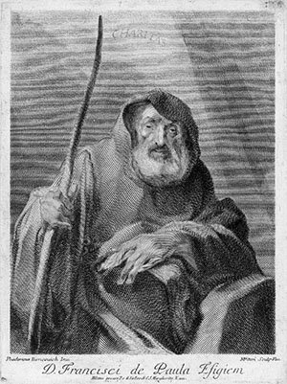
They took the name Hermits of Saint Francis of Assisi and followed the practices of the Franciscans, or the Franciscan Minim Friars. Minim meant they were “the least in the household of God.” To the vows of poverty, chastity, and obedience, Francis added a fourth vow: a perpetual Lenten feast. This order attracted many candidates.
Francis later felt God calling him to defend those who were poor and oppressed. He scolded King Ferdinand of Naples and his sons for their wrongdoing. In 1482, when King Louis XI of France was dying, he begged that Francis come to cure him. Francis at first refused, but Pope Sixtus IV ordered him to care for the king and prepare him for death. When the king saw Francis, he pleaded for a miracle. Francis rebuked him, saying that the lives of kings are in the hands of God. Francis restored peace between France and Great Britain and between France and Spain.
Francis died in the French court. Though his miracles were numerous, he was canonized for his humility and discernment in blending the contemplative life with the active one.

Suggestions
- Tell the students that on Fridays, they can either abstain from meat or perform some other penance. Recommend that they give up snacks between meals one or two days a week.
- Remind the students that no matter how busy their day is, they should still pray.

