Saint Joseph the Worker

Feast day May 1
Joseph understood the importance of work. He was a carpenter—a builder—and probably taught Jesus his trade. Through his work, Joseph honored the Father in heaven and continued the act of creation. He lived in dignity.
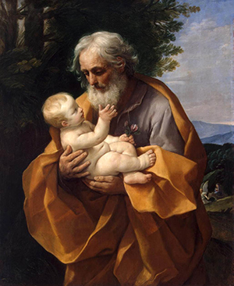
To give workers a patron, the Church turned to Joseph, who had been made the Patron of the Universal Church by Pope Pius IX in 1870 and the model for fathers of families. Joseph was named protector of workers by Pope Benedict XV, and in 1955, the feast of Saint Joseph the Worker on May 1 was proclaimed by Pius the XII.
Let us pray to Saint Joseph for his help in all our work and for those many people who want and need jobs but cannot find them.

Suggestions
- Display your childrens’ best work on May 1.
- Plan a special Arts and Crafts Day for May 1.
- Read the Scripture account of Creation. Discuss how we are made in God’s image, enabling us to make things.
- Click on this link for a short 1 minute video on St Joseph the Worker: https://youtu.be/d-HkZbbo_sw

