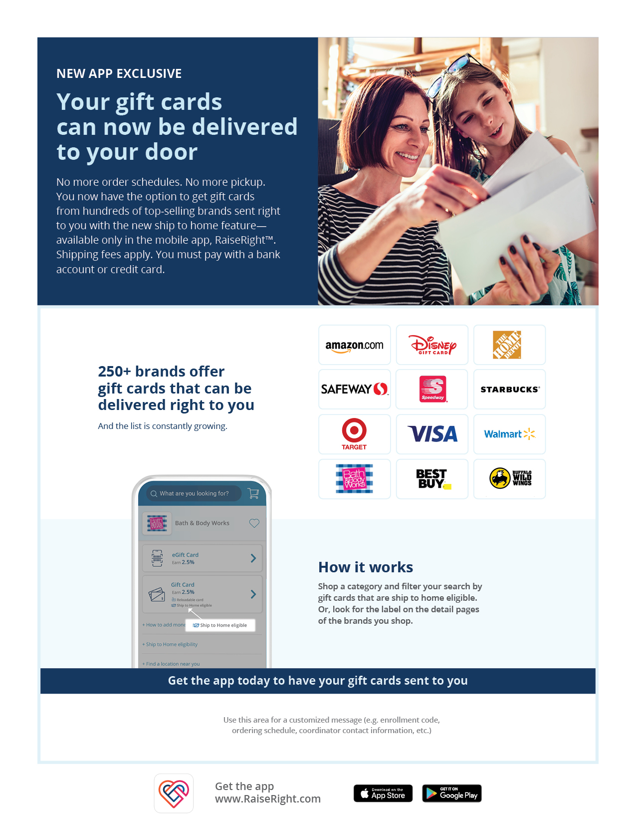

Holy Family School-Parma

Our enrollment code is: LB9E8C2547LL